4COSC0010C Software Development II

MOCK Lab-based Case study

Before you start reading this, please read the test instructions very carefully.

This document provides additional information which you may find useful.

Pet Clinic App project

In this assessment, you will work on a project called 4COSC010C_PetClinicApp, which is a console-based system designed to help manage a pet clinic by allowing pet owners to register and book appointments for their pets.
This project contains two Java files:
- PetClinicApp.java – the main application file containing the menu, logic structure, and method stubs
- PetOwner.java – a class representing the pet owner, which students are required to complete using encapsulation.
You can download, unzip and open the project using IntelliJ. Both the files can be found inside src folder.
Once you have loaded the project, you will see that the main file is a class called App, which includes several method stubs and a global array. A class named PetOwner.java is also provided as a placeholder and must be implemented using encapsulation. The full project is partially developed and ready for you to complete.

MAIN
The main method of the class App contains a welcome message to the user and a call to the method runMenu to show the main menu.
PET SLOTS
The class PetClientApp includes three global arrays for appointment slots, one for each pet type:
static int[] dogSlots = new int[10];
static int[] catSlots = new int[10];
static int[] rabbitSlots = new int[10];

Each array represents 10 available appointment slots for that pet type:
- dogSlots – 10 appointment slots for dogs
- catSlots – 10 appointment slots for cats
- rabbitSlots – 10 appointment slots for rabbits (you are required to add and use this)
Slots are recorded as available (value 0) or taken (value 1).
dogSlots = [0, 1, 0, 0, 0, 0, 0, 0, 0, 0];

In this example, slot 2 (index 1) for dogs is already booked.

MENU

When the program starts, the following menu will be displayed in the IntelliJ output window:
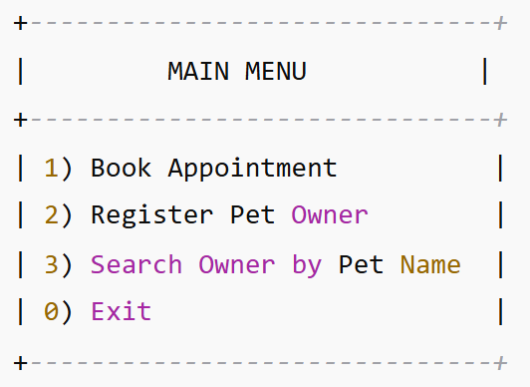
This menu is displayed when the main method calls the runMenu() method.
The runMenu() method uses getOption() to display the options and get the user’s selection using the keyboard.
The program checks if the selected option is valid and calls the correct method based on the user’s choice. The menu will keep repeating until the user selects option 0 (Exit).

REGISTER OWNER METHOD
The registerOwner() method is called when the user selects option 2.
It prompts the user to enter:
- Their full name
- Their pet's name
- A contact number
Then it creates a PetOwner object and stores it in a global array of PetOwner objects.

BOOK APPOINTMENT METHOD
The bookAppointment() method is called when the user selects option 1.
It prompts the user to:
- Choose a pet type (1: Dog, 2: Cat, 3: Rabbit)
- Enter a slot number
If the selected slot is available (value 0), it is marked as booked (set to 1) and a message Appointment booked successfully is displayed.
If the slot is already booked, the user will see Sorry, this slot is not available

SEARCH METHOD
The searchOwnerByPetName() method is called when the user selects option 3.
It prompts the user to enter a pet name and then searches the global array of PetOwner objects.
If a match is found (case-insensitive), the owner's details are displayed using the printOwnerDetails() method.
If not, a message is shown: "No owner found for that pet name.

SAVE TO FILE METHOD
The saveToFile() method is partially developed. You are required to complete it so that:
- All registered pet owner details are saved in ClinicData.txt
- Each line in the file should follow this format:
Name PetName ContactNumber

RUN THE PROJECT ON IntelliJ
- Download and unzip the project folder.
- Open IntelliJ IDEA.
- Select Open, and browse to the unzipped folder.
- Open the PetClinicApp.java file from the src folder.
- Click the green Run button on top of the main method to start the app.
- You should see the main menu appear in the console.

~END~

